**Hands-On 1: Creating Spring Web Project using Maven:**

**Spring Initializr:**

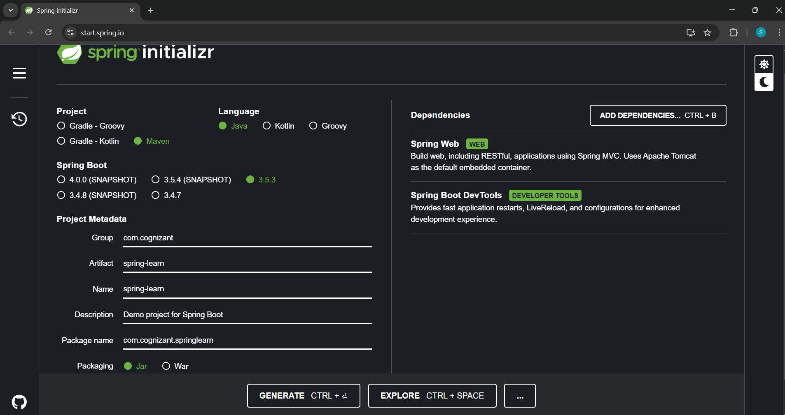

**Project Structure:**

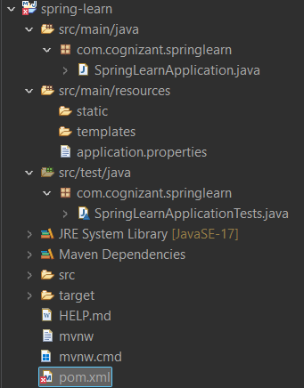

**1. src/main/java**

* com.cognizant.springlearn.SpringLearnApplication.java: main entry point
* Business logic, controllers, services, etc., go here.

**2. src/main/resources**

* application.properties: used to configure port, DB, logging, etc.
* Static resources (HTML, CSS, templates, etc.)

**SpringApplication.java:**

package com.cognizant.springlearn;

import org.springframework.boot.SpringApplication;

import org.springframework.boot.autoconfigure.SpringBootApplication;

import org.slf4j.Logger;

import org.slf4j.LoggerFactory;

*@SpringBootApplication*

public class SpringLearnApplication {

private static final Logger ***LOGGER*** = LoggerFactory.*getLogger*(SpringLearnApplication.class);

public static void main(String[] args) {

SpringApplication.*run*(SpringLearnApplication.class, args);

***LOGGER***.info("SPRINGLEARN APPLICATION STARTED SUCCESSFULLY");

}

}

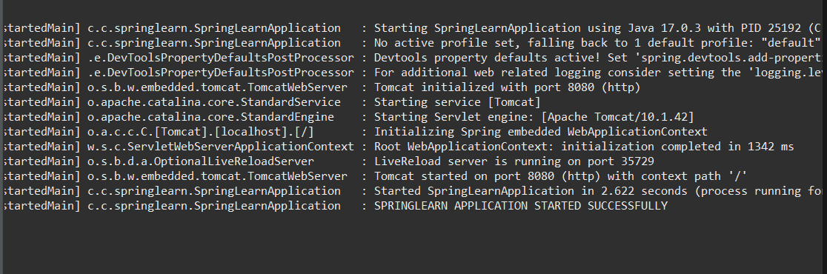

**3. src/test/java**

Contains unit tests or integration tests.

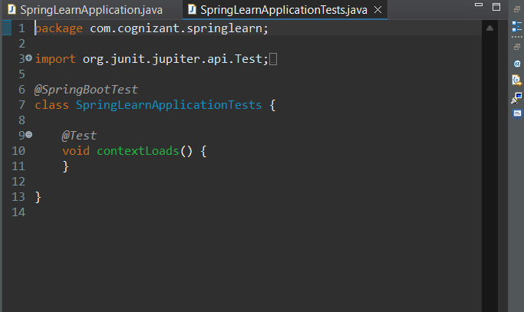

**Dependency Hierarchy:**

